# Packet Sniffing and Spoofing Lab

57117217戚吴祺

## Lab Task Set 1: Using Tools to Sniff and Spoof Packets

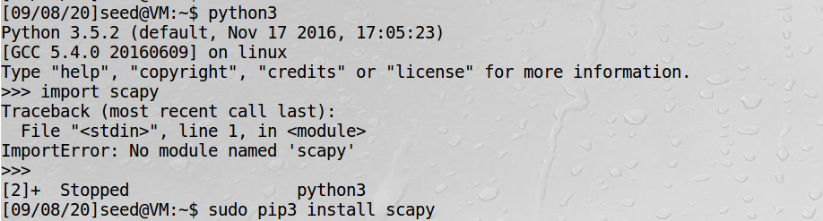

We should run Python using the root privilege.

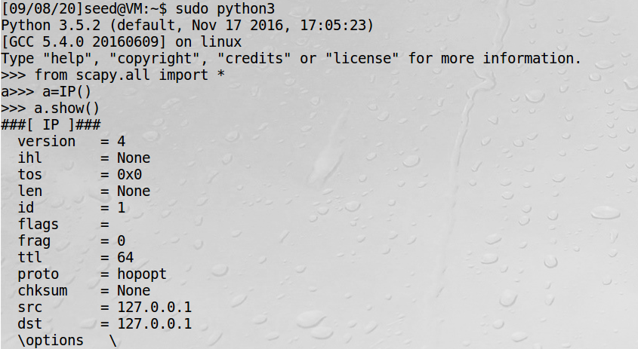

### Task 1.1: Sniffing Packets

Physical machine: 192.168.43.166

Virtual machine(Ubuntu): 192.168.43.161

Virtual machine(kali): 192.168.43.111

Ping vm in physical machine.

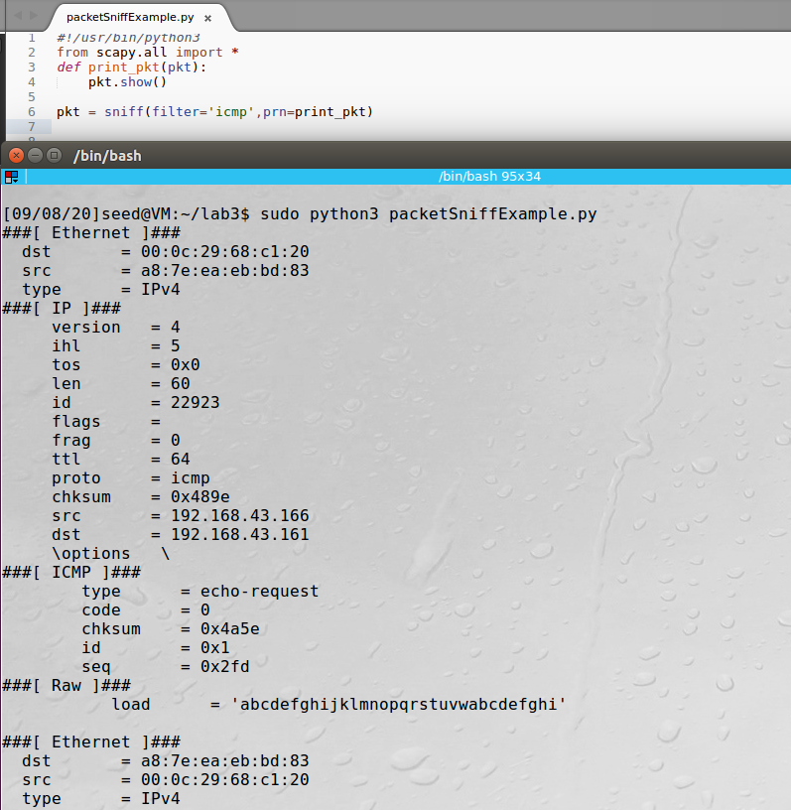

#### **Task 1.1A**

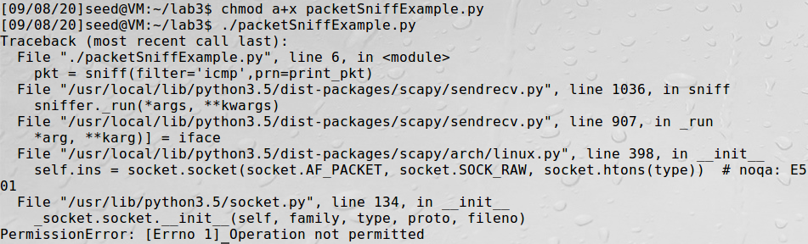

Fail to run the program without root priviledge.

#### Task 1.1B

• Capture only the ICMP packet

The filter is the same as task 1.1A.



Ping vm in other machine.

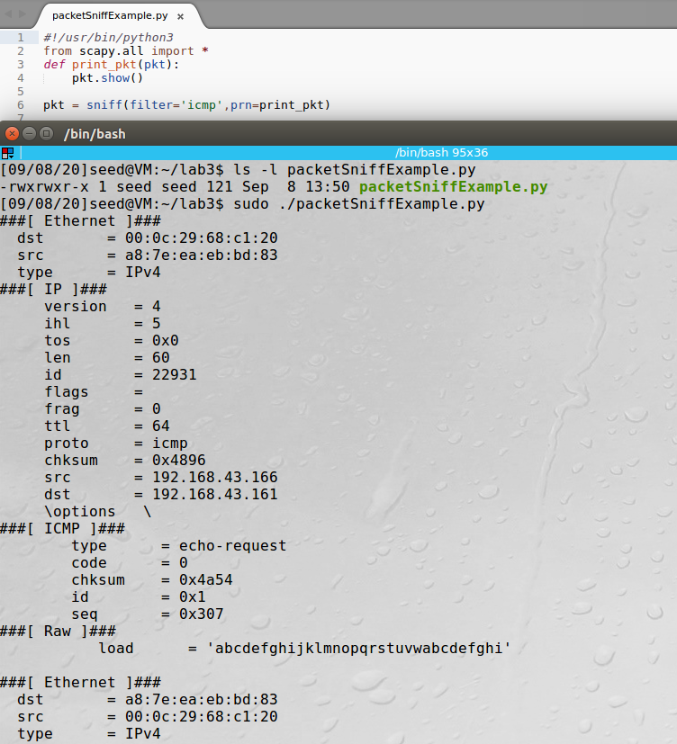

• Capture any TCP packet that comes from a particular IP and with a destination port number 23



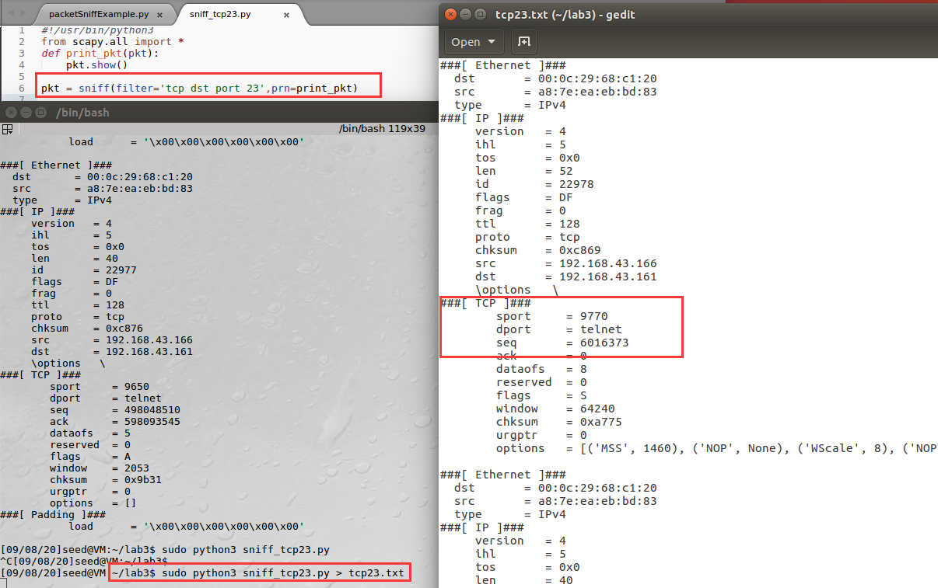 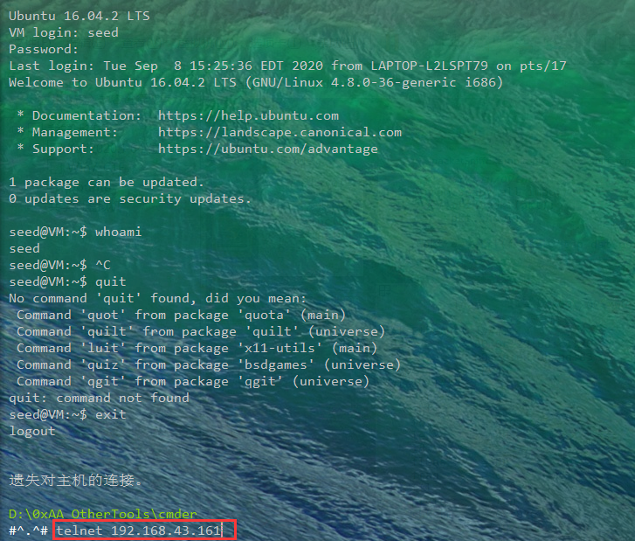

The Telnet protocol defaults to port 23, using tcp protocal.

• Capture packets comes from or to go to a particular subnet. You can pick any subnet, such as 128.230.0.0/16; you should not pick the subnet that your VM is attached to



Pick subnet 192.168.42.0/24 while VM is attached to 192.168.43.0/24.

Capture packets to go to this subnet below.

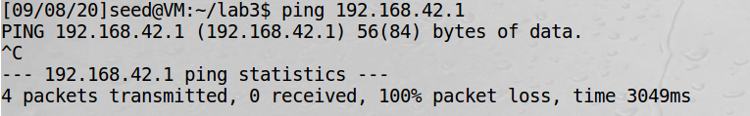

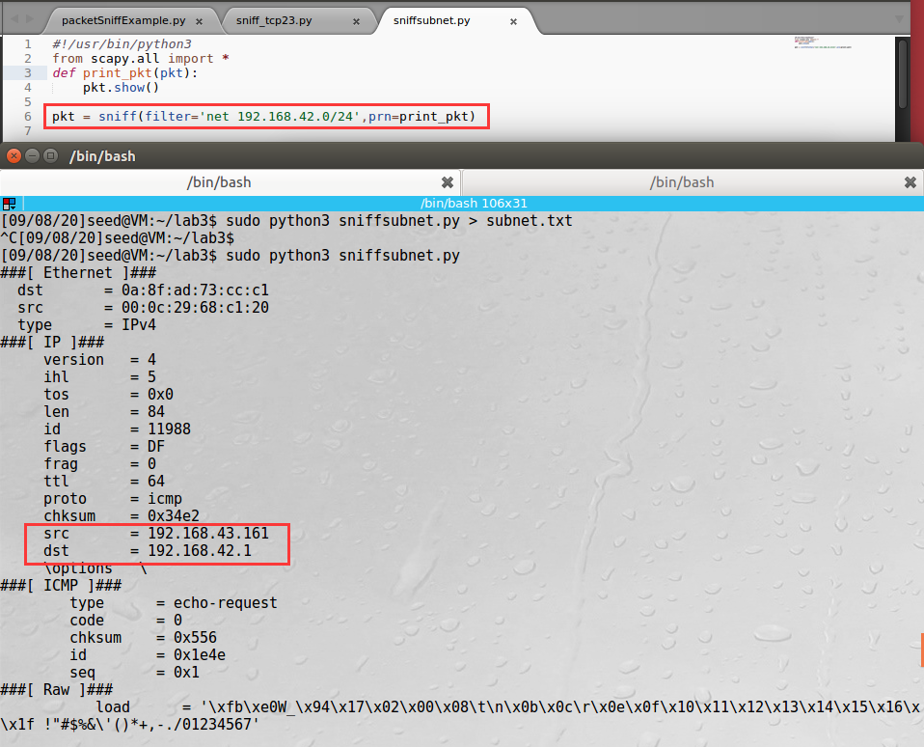

### Task 1.2: Spoofing ICMP Packets

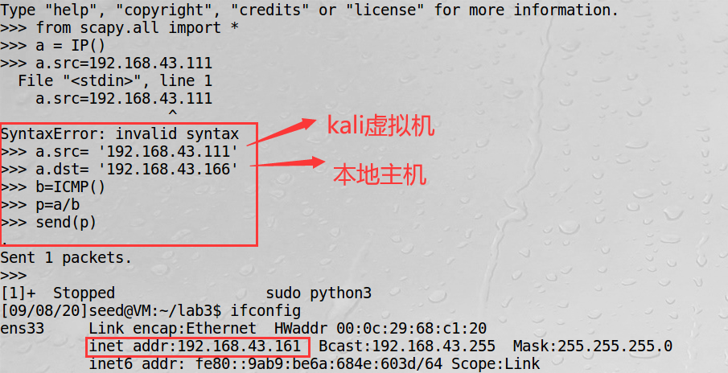

Seed ubuntu spoof 192.168.43.166.

After spoofing, 192.168.43.166 ping reply to 192.168.43.111

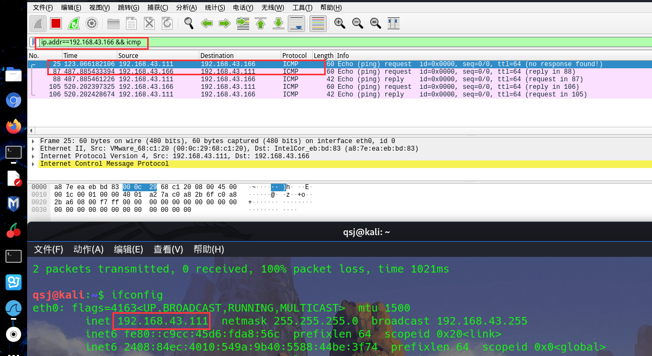

### Task 1.3: Traceroute

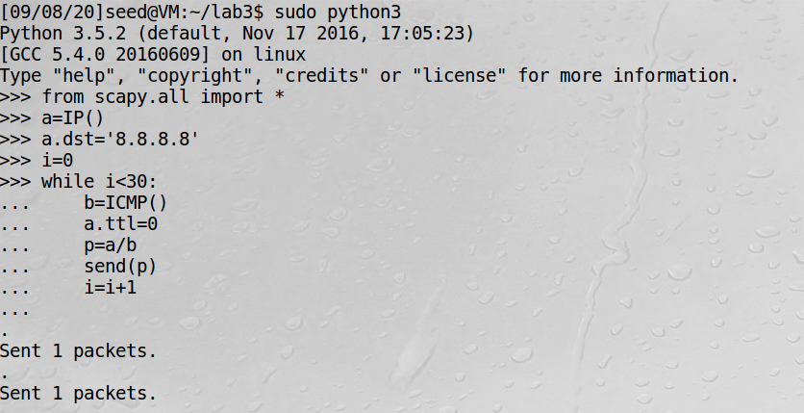

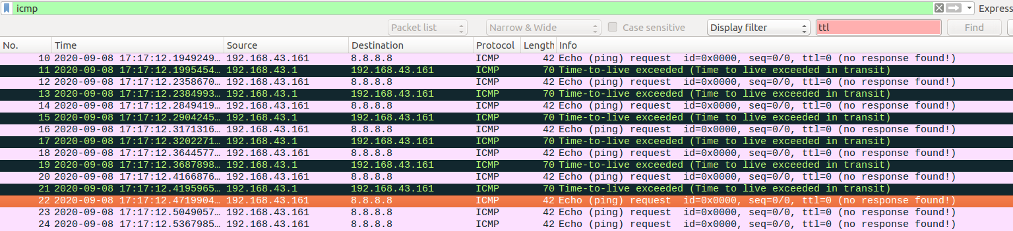

### Task 1.4: Sniffing and-then Spoofing

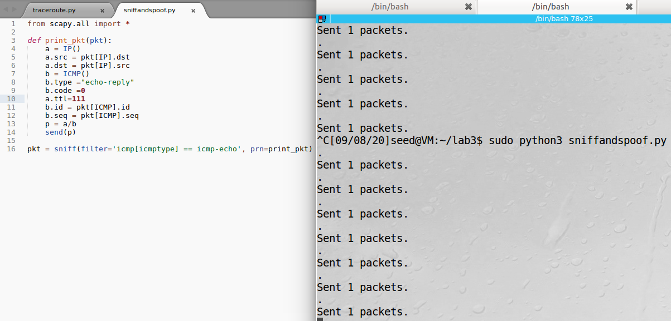

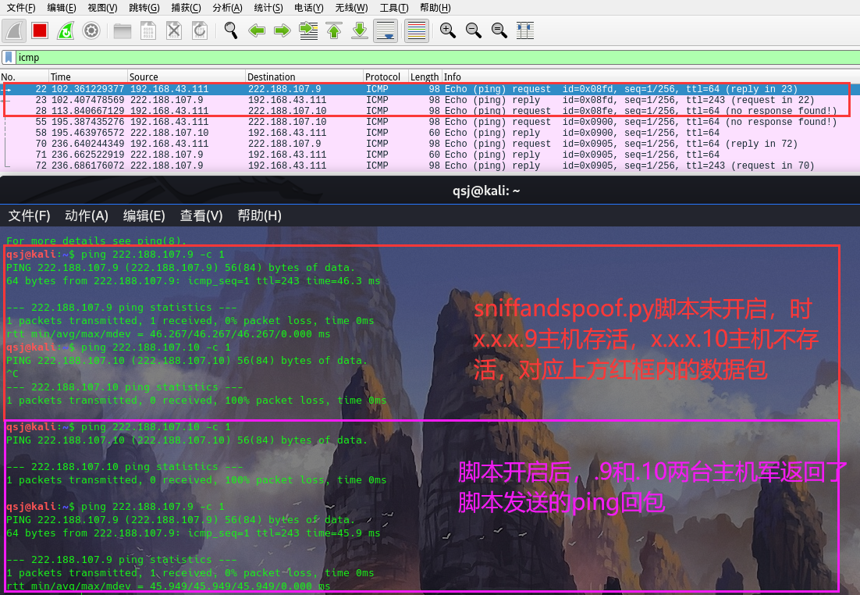

## Lab Task Set 2: Writing Programs to Sniff and Spoof Packets

*It depends on the time*

# ARP Cache Poisoning Attack Lab

(B) Physical machine: 192.168.43.166 a8:7e:ea:eb:bd:83

(M) Virtual machine(Ubuntu): 192.168.43.161 00:0c:29:68:c1:20

(A) Virtual machine(kali): 192.168.43.111 00:0c:29:6c:62:c5

## Task 1: ARP Cache Poisoning

### Task 1A (using ARP request)

On host M, construct an ARP request packet and send to host A.

Map M’s MAC address to B’s IP address in A’s ARP cache.

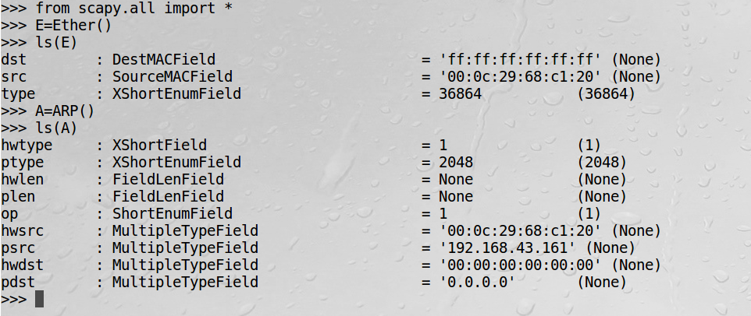

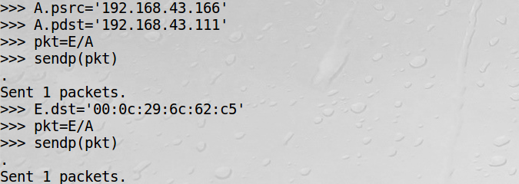

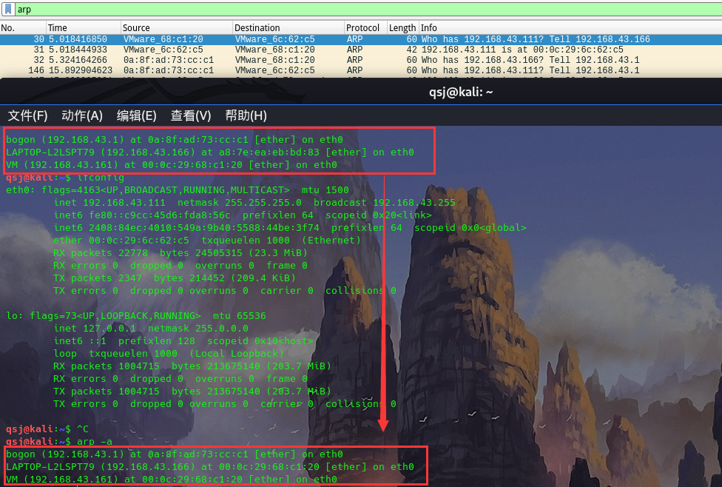

Now, ARP Cache Poisoning has succeeded using ARP request.

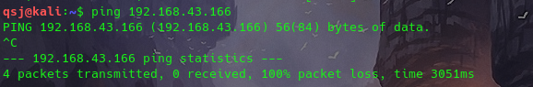

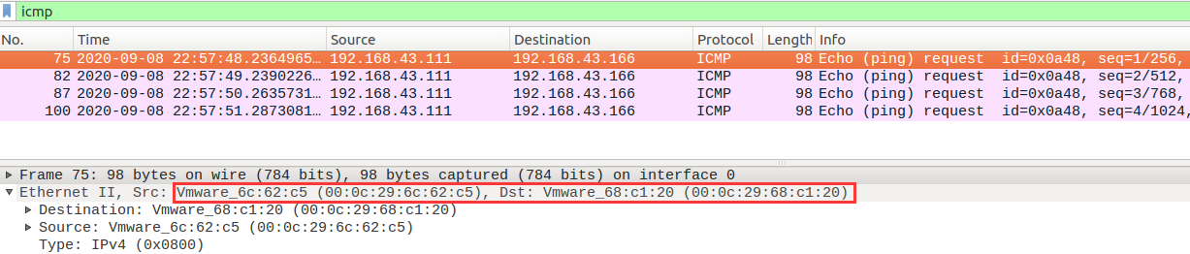

### Task 1B (using ARP reply)

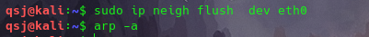

Clear the arp cache.



Set op = 2 to use arp reply.

Change B to 192.168.43.116 00:0c:29:4b:8e:80

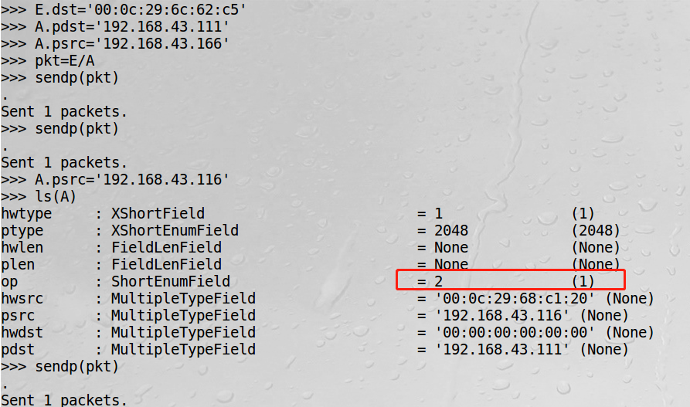

It seems to fail.



### Task 1C (using ARP gratuitous message)

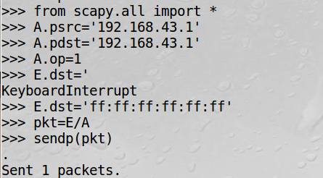

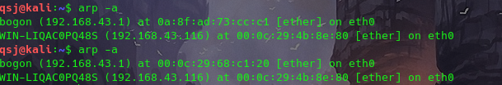

Spoof succeeds.

## Task 2: MITM Attack on Telnet using ARP Cache Poisoning

# IP/ICMP Attacks Lab

## Tasks 1: IP Fragmentation

### Task 1.a: Conducting IP Fragmentation

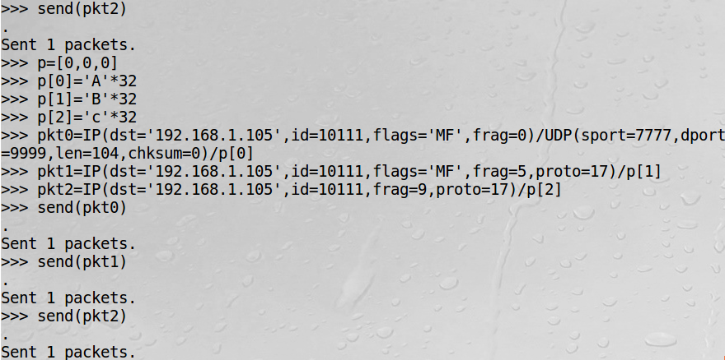

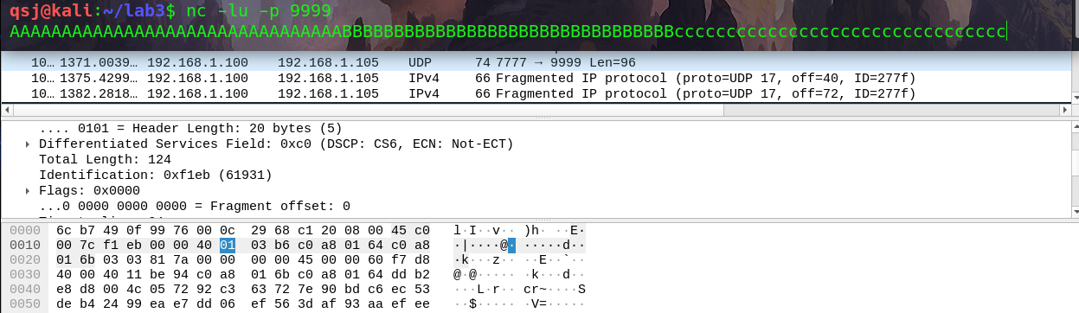

### Task 1.b: IP Fragments with Overlapping Content

aka. teardrop attack

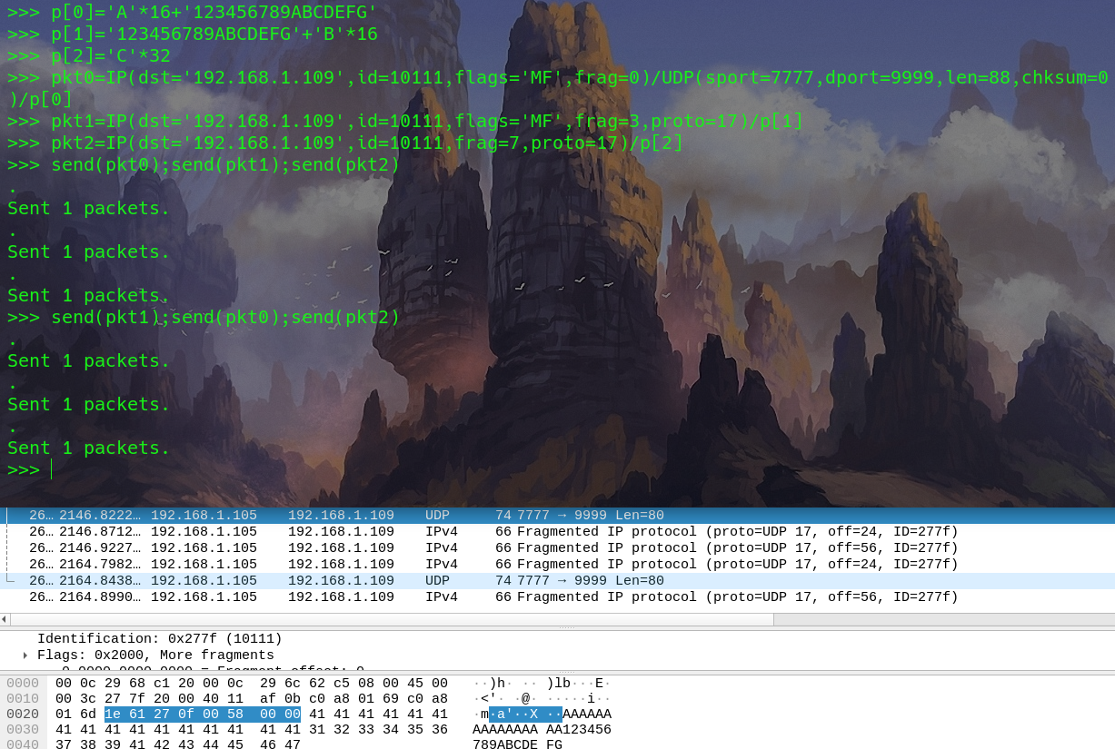

K=16

The results are the same.

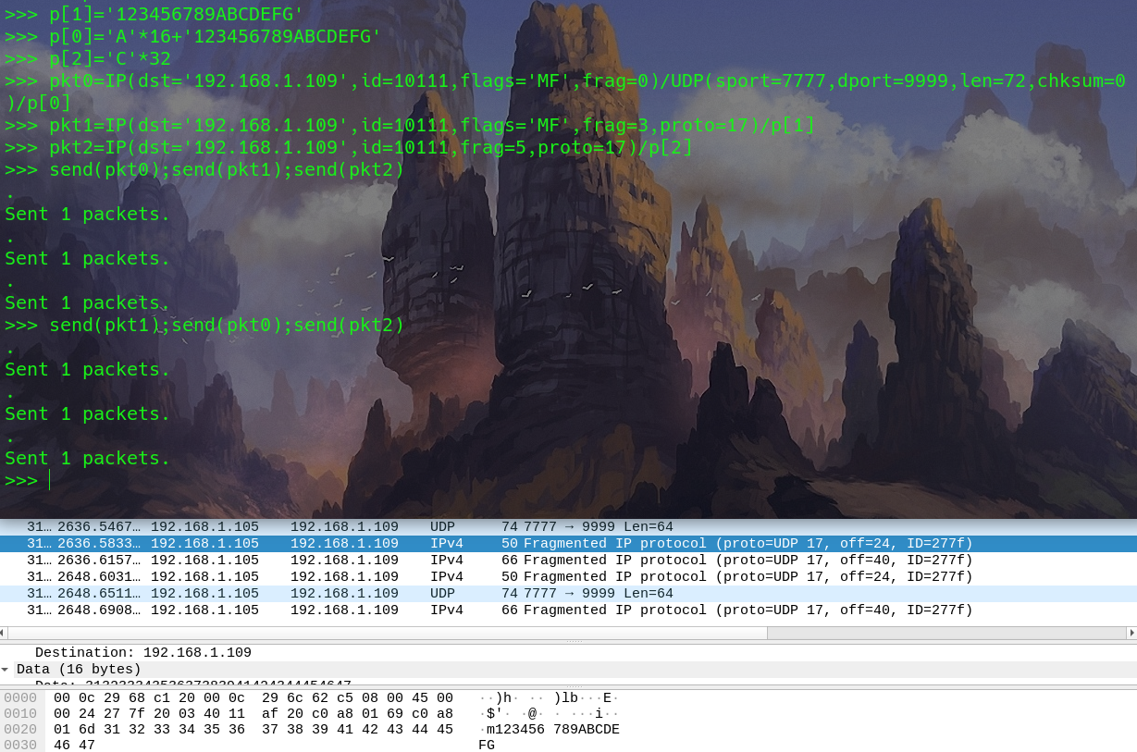It’s weird that the results are still same.

### Task 1.c: Sending a Super-Large Packet

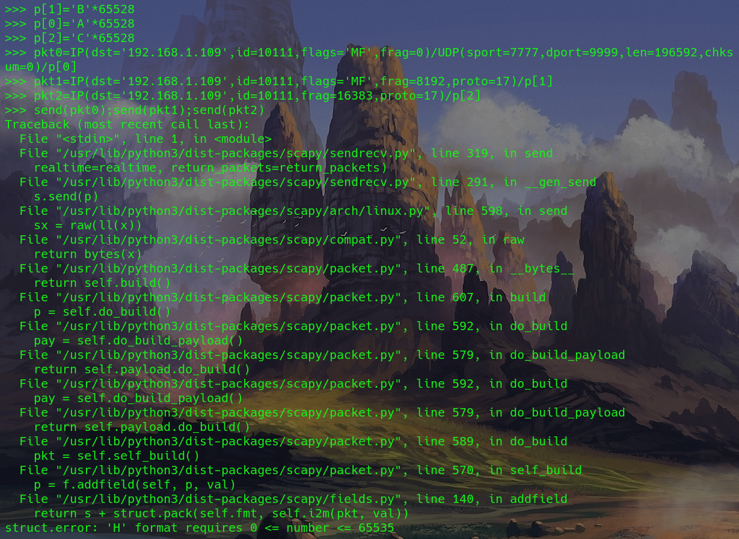

Fail to fix the error.

### Task 1.d: Sending Incomplete IP Packet

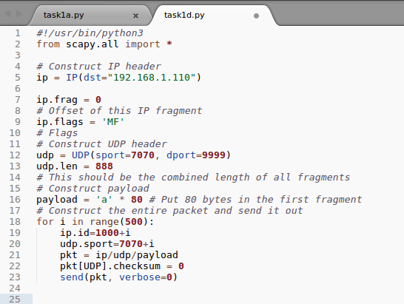

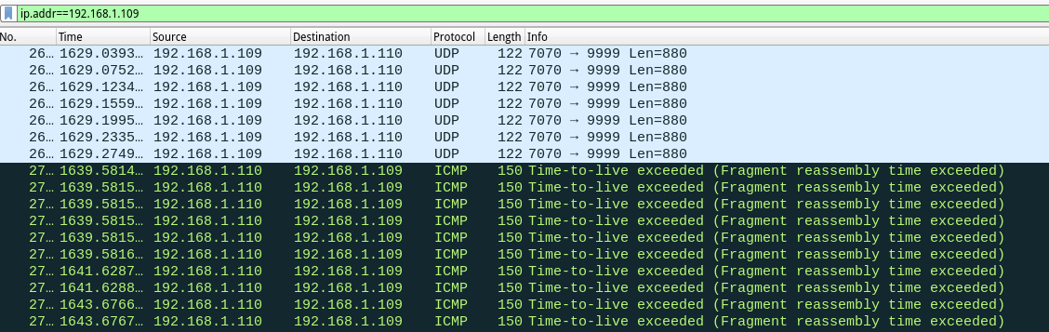

Fragment reassembly time exceeded. Udp server release resource.